**Lab Report: 01**

**Title: Scan Conversion**

*Course title: Computer Graphics Laboratory*

*Course code: CSE-304*

*3rd Year 1st Semester Examination 2022*

**Date of Submission**: 28/05/2023



**Submitted to-**

*Dr. Mohammad Shorif Uddin*

*Professor*

*Department of Computer Science and Engineering*

*Jahangirnagar University*

*&*

*Dr. Morium Akter*

*Associate Professor*

*Department of Computer Science and Engineering*

*Jahangirnagar University*

*Savar, Dhaka-1342*

|  |  |  |
| --- | --- | --- |
| Class Roll | Exam Roll | Name |
| 353 |  | Shanjida Alam |

**Experiment 01: Scan Conversion of a Point**

**Source Code:**

#include<bits/stdc++.h>

#include <graphics.h>

using namespace std;

int main()

{

int gd = DETECT, gm;

initgraph(&gd, &gm, " ");

setbkcolor(WHITE);

float x_f,y_f;

int w,h,i,j;

cout<<"Enter co-ordinates the point for scan conversion: ";

cin>>x_f>>y_f;

int x,y;

x=round(x_f);

y=round(y_f);

putpixel(x, y, GREEN);

getch();

closegraph();

return 0;

}

**Output:**

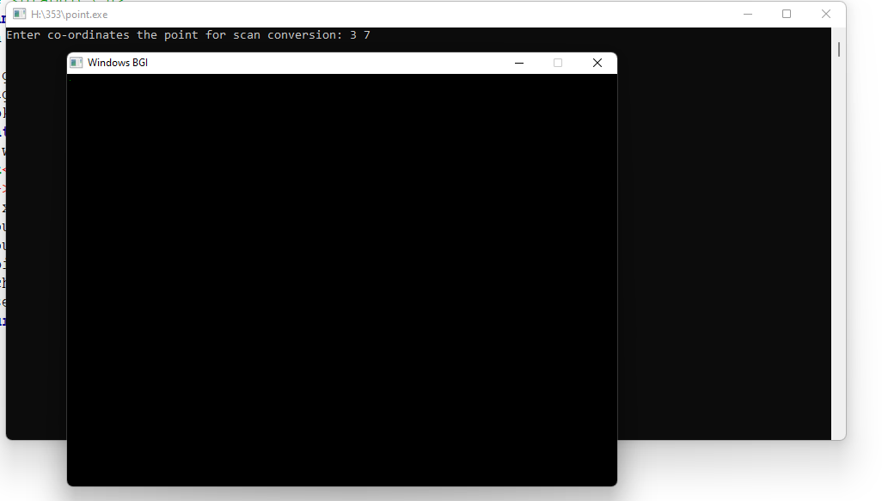

**Experiment 02: Scan Conversion of a Line Using DDA algorithm**

**Source Code:**

#include<bits/stdc++.h>

#include<graphics.h>

#include<conio.h>

#include<stdio.h>

using namespace std;

int main()

{

int gd = DETECT ,gm;

float x, y,dx,dy,step;

int x0, x1, y0, y1,i;

initgraph(&gd, &gm, "");

setbkcolor(WHITE);

cout<<"Enter the two end points of the line: ";

cin>>x0>>y0>>x1>>y1;

dx = (float)(x1 - x0);

dy = (float)(y1 - y0);

if(dx>=dy){

step = dx;

}

else{

step = dy;

}

dx = dx/step;

dy = dy/step;

x = x0;

y = y0;

i = 1;

while(i<= step)

{

putpixel(x, y, RED);

x += dx;

y += dy;

i=i+1;N

}

getch();

closegraph();

return 0;

}

**Output:**

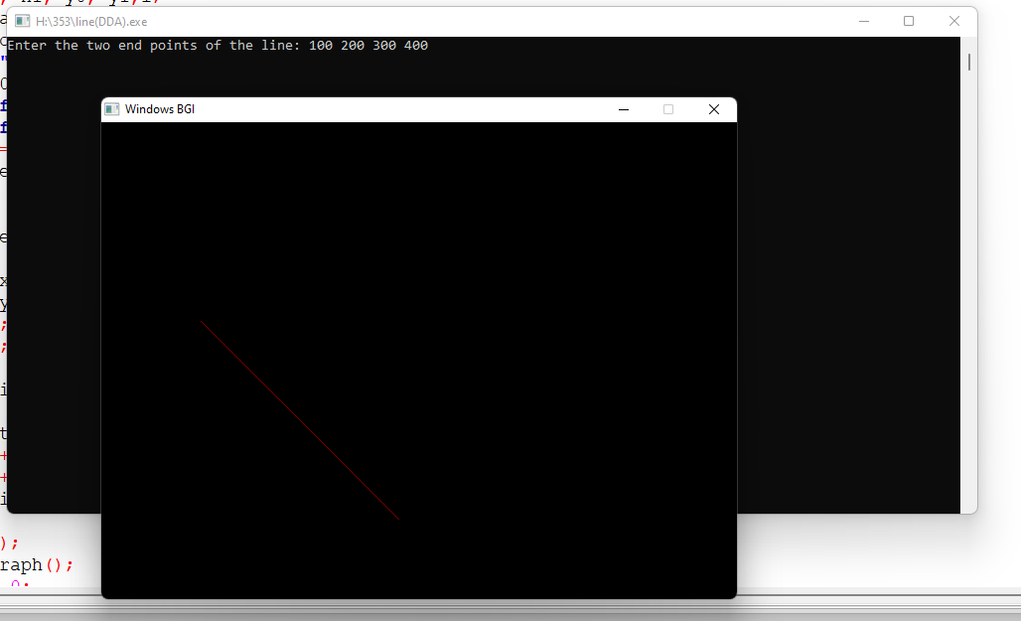

**Experiment 03: Scan Conversion of a Line Using Bresenham algorithm**

**Source Code:**

#include<bits/stdc++.h>

#include<graphics.h>

#include<conio.h>

#include<stdio.h>

using namespace std;

int main()

{

int gd = DETECT ,gm;

float x, y,dx,dy,step;

int x0, x1, y0, y1,i,p;

initgraph(&gd, &gm, "");

setbkcolor(WHITE);

cout<<"Enter co-ordinates for first point: ";

cin>>x0>>y0;

cout<<"Enter co-ordinates for second point: ";

cin>>x1>>y1;

dx = (float)(x1 - x0);

dy = (float)(y1 - y0);

p=(2*dy)-dx;

x = x0;

y = y0;

i = 1;

while(x<x1)

{

if(p>=0)

{

putpixel(x,y,BLUE);

y=y+1;

p=p+(2*dy)-(2*dx);

}

else

{

putpixel(x,y,7);

p=p+2*dy;}

x=x+1;

}

getch();

closegraph();

return 0;

}

**Output:**

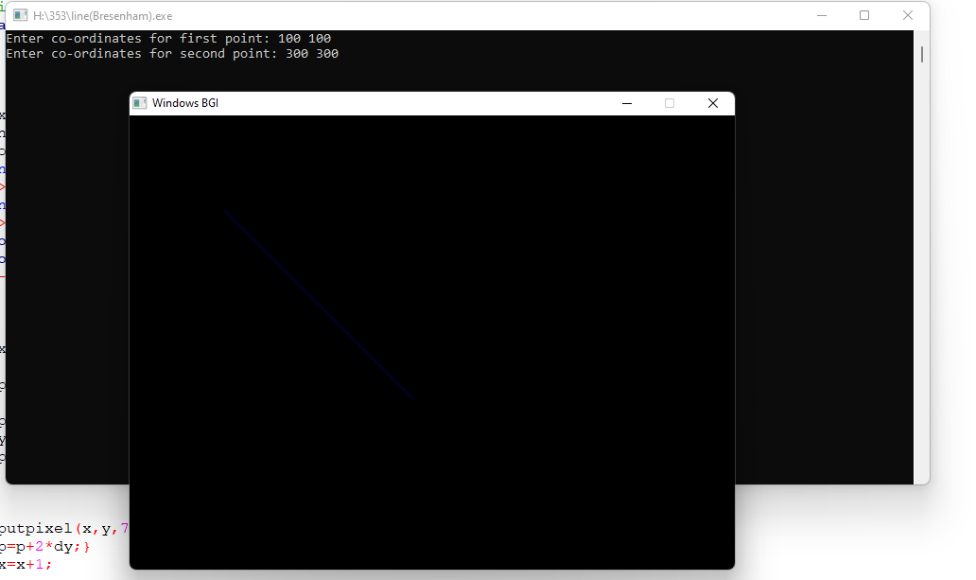

**Experiment 04: Scan Conversion of a Circle Using Bresenham algorithm**

**Source Code:**

#include <bits/stdc++.h>

#include <graphics.h>

using namespace std;

int main()

{

int gd = DETECT, gm;

initgraph(&gd, &gm, "");

int xc,yc,radius;

cout<<"Enter the center coordinates (x,y): ";

cin>>xc>>yc;

cout<<"Enter the radius of the circle: ";

cin>>radius;

int x = 0;

int y = radius;

int d = 3 - 2 * radius;

while (x <= y)

{

putpixel(xc + x, yc + y, RED);

putpixel(xc - x, yc + y, RED);

putpixel(xc + x, yc - y, RED);

putpixel(xc - x, yc - y, RED);

putpixel(xc + y, yc + x, RED);

putpixel(xc - y, yc + x, RED);

putpixel(xc + y, yc - x, RED);

putpixel(xc - y, yc - x, RED);

if (d <= 0)

{

d += 4 * x + 6;

}

else

{

d += 4 * (x - y) + 10;

y--;

}

x++;

}

getch();

closegraph();

return 0;

}

**Output:**

